**T Series**

Line of telescopic cranes, made to satisfy customers in need of a crane which is compact, lights and easy to operate. Compact Light Easy to operate

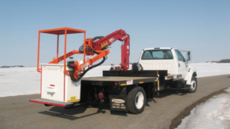

805T

Max. Lifting capacity (kg)

2080

Lifting Moment Class (tm)

3

Max. Extension reach (m)

7.5

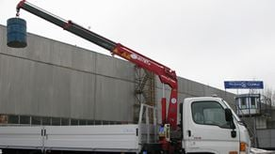

807NT

Max. Lifting capacity (kg)

3300

Lifting Moment Class (tm)

7

Max. Extension reach (m)

8.45

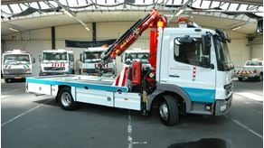  
811NT

Max. Lifting capacity (kg)

4060

Lifting Moment Class (tm)

10

Max. Extension reach (m)

9.55

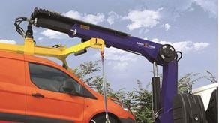

818NGT

Max. Lifting capacity (kg)

6370

Lifting Moment Class (tm)

16

Max. Extension reach (m)

10.3



821NGT

Max. Lifting capacity (kg)

8335

Lifting Moment Class (tm)

19

Max. Extension reach (m)

12.08



824NGT

Max. Lifting capacity (kg)

8480

Lifting Moment Class (tm)

21

Max. Extension reach (m)

12.08



905T

Max. Lifting capacity (kg)

2080

Lifting Moment Class (tm)

3

Max. Extension reach (m)

7.5



907NT

Max. Lifting capacity (kg)

3300

Lifting Moment Class (tm)

7

Max. Extension reach (m)

8.45